MRE 320

Individual Project Assignment

Group Member: Qiuhao Ma & Jiayi Yuan

Milestone#1: Get familiar with your sensor and propose testing plans

* For the Square FSR.

1. What Square FSR is?

FSRs are sensors that allow you to detect physical pressure, squeezing and weight. FSRs are made of plastic and the connection tab is crimped on delicate material.

They are simple to use and low cost. This sensor is an Alpha MF02A-N-221-A01 FSR with a 38mm square sensing region. Note that this sensor can't detect *where* on the square you pressed.  
FSRs are basically a resistor that changes its resistive value (in ohms Ω) depending on how much its pressed. These sensors are fairly low cost, and easy to use but they're rarely accurate. They also vary some from sensor to sensor perhaps 10%. So basically when you use FSRs you should only expect to get ranges of response. While FSRs can detect weight, they're a bad choice for detecting exactly how many pounds of weight are on them.

1. How to connect the sensor to Arduino ?

1. Arduino code

const int FSR_PIN = A0;

// Pin connected to FSR/resistor divider

// Measure the voltage at 5V and resistance of your 3.3k resistor, and enter

// their value's below:

const float VCC = 4.98;

// Measured voltage of Ardunio 5V line

const float R_DIV = 3230.0;

// Measured resistance of 3.3k resistor

void setup()

{

  Serial.begin(9600);

  pinMode(FSR_PIN, INPUT);

}

const int threshold = 40823.3;

//value for force in Grams( grams is defined later) roughly 90lbs

int countAboveThreshold = 0;

// counts how many long the threshold value is being match detected

const int iterationsToHold = 600;

// 20min/2sec (loopdelay)= 600. if the threshold is >= threshold then signal send

const int loopDelay = 2000;

void loop()

{

  int fsrADC = analogRead(FSR_PIN);

// If the FSR has no pressure, the resistance will be

// near infinite. So the voltage should be near 0.

  if (fsrADC != 0) // If the analog reading is non-zero

  {

// Use ADC reading to calculate voltage:

    float fsrV = fsrADC * VCC / 1023.0;

// Use voltage and static resistor value to

// calculate FSR resistance:

    float fsrR = R_DIV * (VCC / fsrV - 1.0);

    Serial.println("Resistance: " + String(fsrR) + " ohms");

// Guesstimate force based on slopes in figure 3 of

// FSR datasheet:

    float force;

    float fsrG = 1.0 / fsrR;

// Calculate conductance

// Break parabolic curve down into two linear slopes:

    if (fsrR <= 600)

      force = (fsrG - 0.00075) / 0.00000032639;

    else

      force =  fsrG / 0.000000642857;

    Serial.println("Force: " + String(force) + " g");

    Serial.println();

 if (force >= threshold) {

      countAboveThreshold += 1;

    } else {

      countAboveThreshold = 0;

    }

    if (countAboveThreshold == iterationsToHold) {

      Serial.println("person is resting on grate#X ");

//Placeholder action to communicate with GSM sensor FONA-mini cellular SMS breakout

    }

    delay(loopDelay);

  }

  else

  {

// No pressure detected

  }

}

1. Screenshot of the sensor readings

* For Circular Soft Potentiometer. Here is the picture of it.

1. Text

   Description automatically generatedWhat Circular Soft Potentiometer is?

This shape is a circular soft potentiometer with a donut-shaped sensing region whose outer diameter is 55.96mm/2.2in and inner diameter is 35.63mm/1.4in. There is a nominal 10K resistance across the two outer leads. The middle pin resistance with respect to either of the outer pins changes depending on where on the strip one presses. When no pressure is applied, the middle pin floats, so be sure to use some sort of weak pullup, such as 100K ohm. To use Connect one side pin to ground via a 10K resistor in series. Connect the other side pin to your Vcc power line (3V, 5V etc) via a different 10K resistor in series. Then read the analog voltage on the center pin. It will range from 1/3 Vcc to 2/3 Vcc . Do not connect to Ground and Power directly!

Dimensions:

* Length: 115.91mm/4.56in
* Width: 65.63mm/2.584inn
* Thickness: 0.58mm/0.023in
* Weight: 2.05g/0.072oz

1. How to connect the sensor to Arduino?

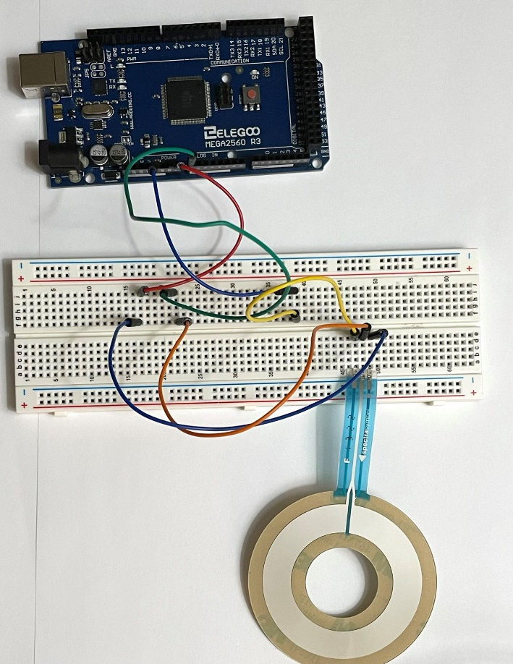

1. Arduino code

float floatMap(float x, float in_min, float in_max, float out_min, float out_max) {

  return (x - in_min) * (out_max - out_min) / (in_max - in_min) + out_min;

}

// the setup routine runs once when you press reset:

void setup() {

  // initialize serial communication at 9600 bits per second:

  Serial.begin(9600);

}

// the loop routine runs over and over again forever:

void loop() {

  // read the input on analog pin A0:

  int analogValue = analogRead(A0);

  // Rescale to potentiometer's voltage (from 0V to 5V):

  float voltage = floatMap(analogValue, 0, 1023, 0, 5);

  float degree = floatMap(analogValue, 0, 1023, 0, 360);

  float resistor = floatMap(analogValue, 0, 1023, 0, 10000);

  // print out the value you read:

  Serial.print("Position Degree: ");

  Serial.print(degree);

  Serial.print(", Resistor: ");

  Serial.println(resistor);

  delay(1000);

}

}

1. Screenshot of the sensor readings

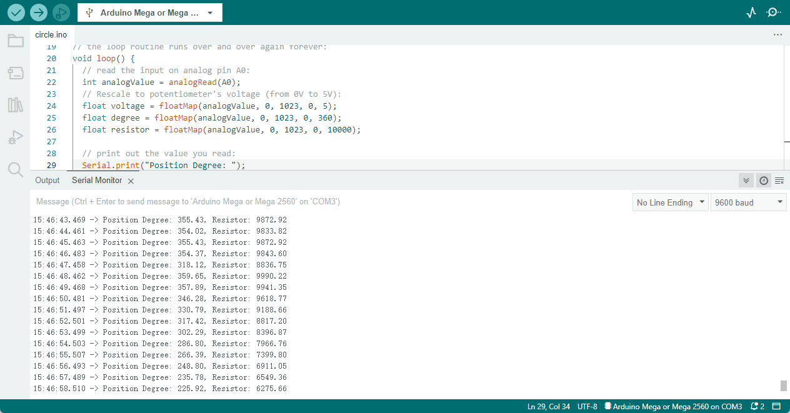

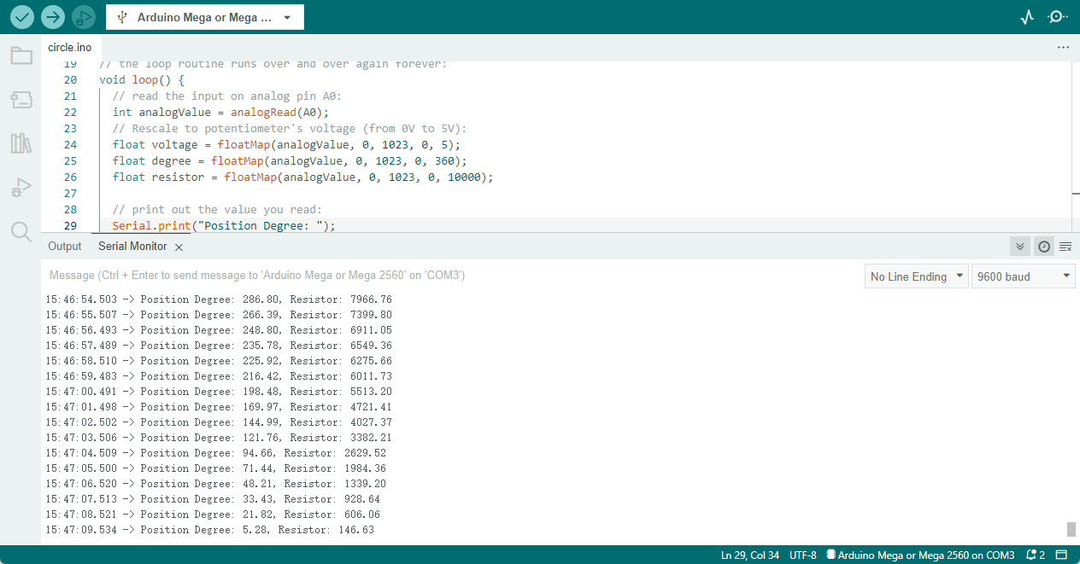

* For long flex/bend sensor, the picture of it is shown below.
  1. What long flex/bend sensor is?

This sensor can detect flexing or bending in one direction. These sensors are easy to use, they are basically resistors that change value based on how much they're flexed. If they're unflexed, the resistance is about ~10KΩ. When flexed all the way the resistance rises to ~20KΩ. You can use an analog input on a microcontroller (with a pullup resistor) or a digital input with the use of a 0.1uF capacitor for RC timing. The bottom part of the sensor (where the pins are crimped on) is very delicate so make sure to have strain relief - such as clamping or gluing that part so as not to rip out the contacts!

* 1. How to connect the sensor to Arduino?

* 1. Arduino code

#define sensorPin  A0 // Flex Sensor is connected to this pin

#define PWMPin  6 // LED is attached to this Pin

float VCC = 5; // Arduino is powered with 5V VCC

float R2 = 10000; // 10K resistor is

float sensorMinResistance = 16700; // Value of the Sensor when its flat

float sensorMaxResistance = 18200; // Value of the Sensor when its bent at 90*

void setup() {

  Serial.begin(9600); // Initialize the serial with 9600 baud

  pinMode(sensorPin, INPUT); // Sensor pin as input

}

void loop() {

  int ADCRaw = analogRead(sensorPin);

  float ADCVoltage = (ADCRaw * VCC) / 1023; // get the voltage e.g (512 * 5) / 1023 = 2.5V

  float Resistance = R2 * (VCC / ADCVoltage - 1); // Calculate Resistance Value

  uint8_t ReadValue = map(Resistance, sensorMinResistance, sensorMaxResistance, 0, 255); // map the values 16700 to 0  18200 to 255

  analogWrite(PWMPin, ReadValue); // Generate PWM Signal

  // Print Debug Information

  Serial.print(Resistance);

  Serial.print("  ");

  Serial.println(ReadValue);

  delay(100);

}

* 1. Screenshot of the sensor readings

* Testing plans (Include methods, equipment, and explanation of your proposed

experimental procedure).

**For Square FSR**

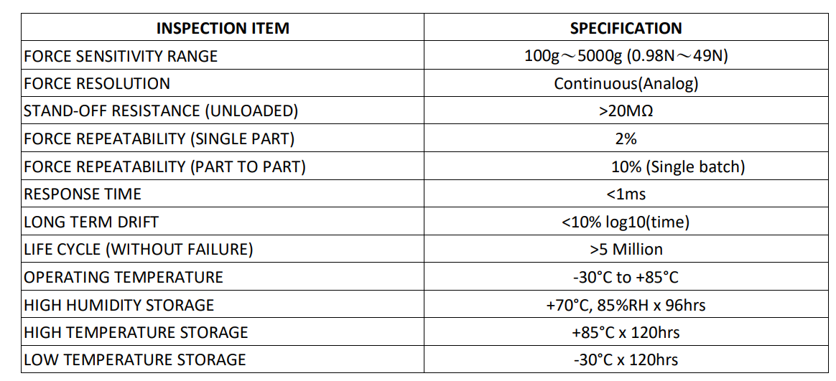

**For Circular Soft Potentiometer**

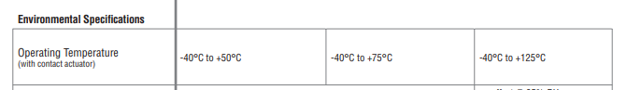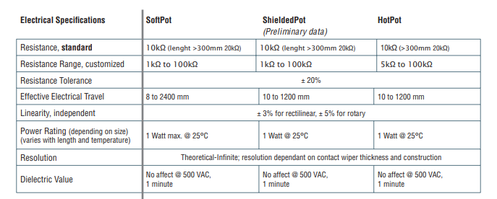

**For Long flex/bend sensor**

Dimensions:

Length: 112.5mm/4.4in

Width: 6.38mm/0.25in

Thickness: 0.5mm/0.2in

Weight: 0.5g/0.017g

**图形用户界面

**

**Testing plan**

**For square:**

**Resolution:** To test this, we design to adding water into an empty bottle and increase the weight a little at a time, in other word, to use gravity as pressure, to test how much pressure is required each time to make the sensor sense the pressure change.

**Equipment:** A Kitchen Scale, an empty bottle and water.

**Dynamic range:** We design to use the weight to test the minimum weight or pressure that can change the sensor value. And the maximum weight or pressure value that the sensor can sensed.

**Equipment:** A Kitchen Scale, weights.

**Sensitivity:** We design to calculate the slope of the image using the image automatically generated by Arduino.

**Equipment:** Arduino, calculator.

**For long:**

**Dynamic range:** To find the minimum angle of bend that can be sensed by this sensor, and the maximum angle of bend that can sensed by this sensor.

**Equipment:** protractor

**Sensitivity:** We design to calculate the slope of the image using the image automatically generated by Arduino.

**Equipment:** Arduino, calculator.

**For circular:**

**Accuracy:** Error between actual measured angle and Arduino displayed measured angle.

**Equipment:** protractor, Arduino.

**Linearity:** Get the plot of the data we measured. Then see weather the image is linear.

**Equipment:** protractor, Arduino.